Instructions for using BusMonitor with Resideo Water Heater Controls

EnvBusMon is the program that is used to monitor EnviraCOM network traffic and is also capable of sending messages onto the bus with content as desired. The program is used with the Honeywell Modulating IFC to observe system status / behavior and to set the desired firing rate when testing a furnace in the lab – when using a communicating thermostat one cannot easily manually control the firing rate of the appliance.

Setup:
- Connect properly programmed serial adapter to the EnviraCOM network and PC used for testing.
- Unzip the EnvBusMon program to the desired folder on the PC.
- Place a recent copy of the “EBMMsgDecodeFile.txt” file from the EnviraCOM specifications in the folder with EnvBusMon (C:\BusMon above).
- Select the appropriate COM port in the EnvBusMon program (upper right corner)
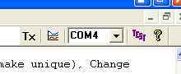

The zip file containing the bus monitor files also include a user manual that helps explain various functionality of the program. One useful feature described in the manual is the ability to write scripts. Scripts automate the sending of messages so a user for example can query a message at a periodic interval.

Sending Messages to the Bus:
The toolbar across the top of the program is used to send data to the EnviraCOM bus.

Press the “Tx” button once the desired message and data are filled in.

In the example above an “Alarm History” query is sent to device 0 (first device on the bus) with medium priority. The data bytes in the message are 0xff and 0xff as shown in the text field immediate to the left of the Tx button.

All data bytes are in 2-digit Hexadecimal format, i.e. 0 through F is 0 through 15 in decimal. The standard windows calculator can be used in scientific mode to see the difference:
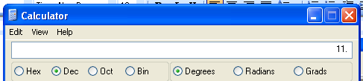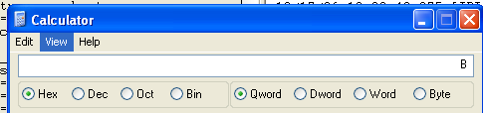

Useful messages for monitoring a water heater control:

Message: DHW Cylinder Setpoint.
This message can be used a query of change request.
Sending a query will ask the device to report its current setpoint.
Sending a change request will request the device to change its current setpoint to the new value in the data field.
Setpoint values are transmitted in degC*1000.
In the example above the data bytes 13 and 18 represent hex number 1318 which corresponds to 120degF.
120degF = 48.89degC → 4889 = 0x1318
Some example setpoint are included below for convenience.
100degF = 0E C1
110degF = 10 ED
120degF = 13 18
130degF = 15 44
140degF = 17 70

The setpoint can only be lowered from the knob setpoint. Enviracom cannot raise the setpoint higher than the knob setpoint.

Message: DHW Cylinder Temperature water heater query.
This message asks the control to report the sensed water temperature

Message: Device Status water heater query.
This message asks the control to report the current status of the igntion control: ignition state and flame current are generally the variables of interest although other information such as valve on/off state or ignition on/off are also available.
Other Information for Reference
The BusMonitor tool has a few additional features which may prove useful in working with an EnviraCOM system.

1) List of EnviraCOM data of interest
Although the right-hand portion of the window can be setup to scroll as new messages are seen on the bus, sometimes only a few data items are really of interest. In this case the left-hand portion of the screen maybe setup to monitor these critical items. To set this up perform the following:

Double-click in the grey area on the left. A configuration window pops up as shown:
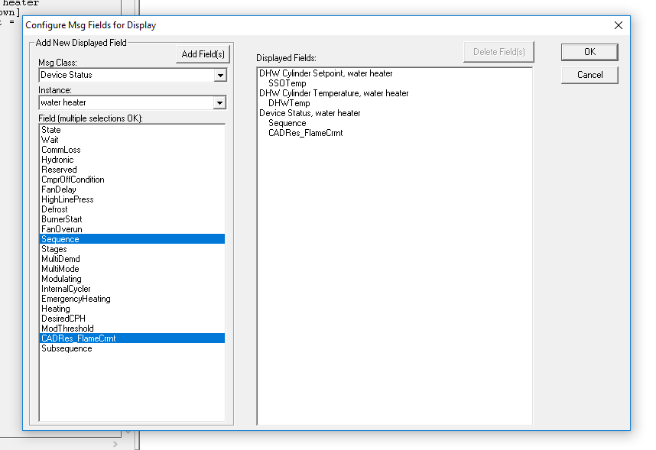

On the right portion of the window it shows items that have been added to the displayed fields list. To add additional fields one must select the appropriate msg class and instance, followed by the fields of interest (you may select more than one).

See below for an example selecting the following fields:
Device Status, gas heat, Sequence (i.e. IDLE, PREPURGE, RUNNING)
Device Status, gas heat, CADRes_FlameCurrnt (Flame current – nA)
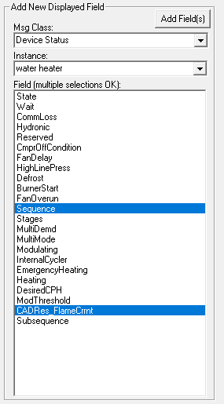

Next click “Add Field(s)” to add them to the displayed fields list.

Useful EnviraCOM Data Fields
For a water heater IFC the following fields may be of interest during testing:
- DHW Cylinder Setpoint, water heater
  - SSOTemp (setpoint)
- DHW Cylinder Temperature
  - DHWTemp
- Device Status, water heater
  - Sequence (i.e. IDLE, HSIWARMUP, RUNNING)
  - CADRes_FlameCurrnt (Flame current – nA)

Scripts:
Below is an example script that queries device status, waits for the bus to go idle (no one transmitting), and then waits one second. Copying and pasting this section over and over would result in BusMonitor querying for device status approximately once per second. Unfortunately there is no way to implement loops or repetitions in the scripts so the following lines would have to be repeated ~60 times to log an entire minute.

The following lines pasted into a plain text document (e.g. notepad) and named with a .spt extension can be loaded into BusMonitor for execution.

; Medium priority, Device Status, water heater, Query,
+-+++++-+--+++----++++-----+-----+--++++-+++++-+-----+--------
; Wait for bus idle
I
; wait 1 second
W1

Note that once a script is started, it runs until completion. BusMonitor will have to force closed if it is desired to stop the script early.

Note also that it is possible to remove (or comment out with a ; ) the one second wait (W1) if more frequent reporting is desired.

